**Solving Exponential and Logarithmic Equations**

There are a few different techniques we can use to solve these types of equations, the first of which requires finding two functions or expressions with the same base. This occasionally requires using the properties of exponents and logarithms to manipulate the expressions.

$$b^{S}=b^{T} ⟺ S=T ⟺ \log_{b}\left(S\right)=\log_{b}\left(T\right)$$

For example:

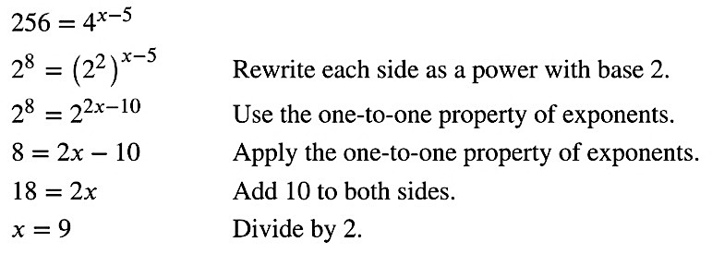

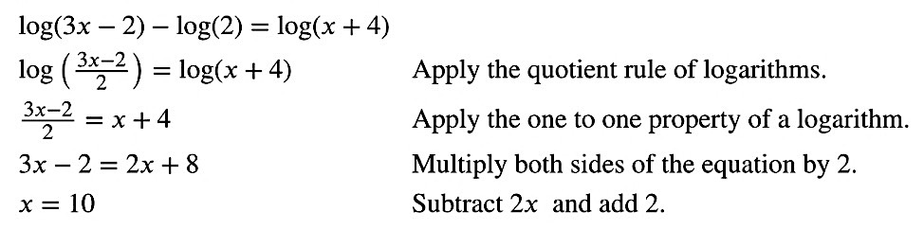

Example 1: Solve the following exponential and logarithmic equations.

$3^{4x-7}=\frac{3^{2x}}{3}$ $8^{x+2}={16}^{x+1}$ $\log_{7}\left(x^{2}\right)=\log_{7}\left(x+3\right)$

$\ln\left(2\right)+\ln\left(3x-5\right)=\ln\left(5x\right)$ $\sqrt{\frac{1}{5}}=5^{4-3x}$

A second technique requires a conversion from exponential to logarithmic, or from logarithmic to exponential. In both cases, remember that these are simply operations and thus we may need to leave our solutions in exponential or logarithmic form.

$$b^{S}=T ⟺ \log_{b}\left(T\right)=S$$

For example:

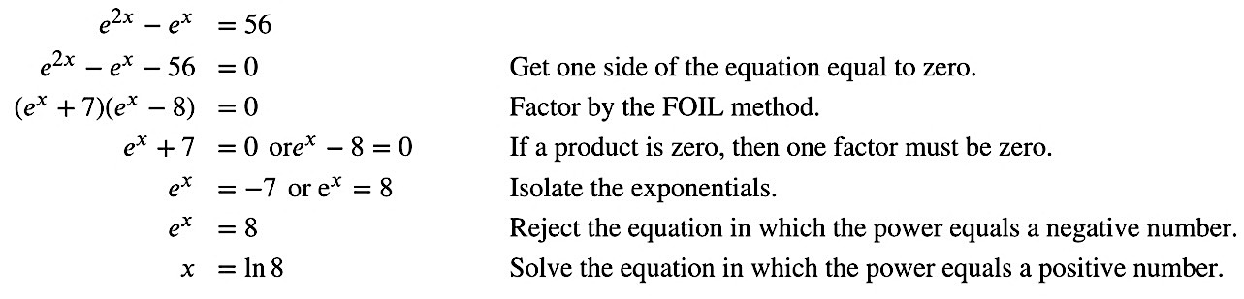

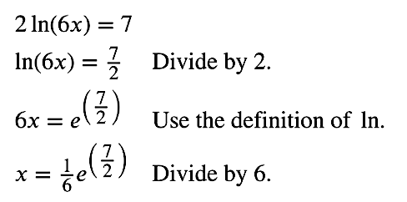

Example 2: Solve the following exponential and logarithmic equations.

$2^{2x-5}+5=20$ $\log_{4}{(2x-1)}=3$ $3^{x+1}=-2$

A third technique requires understanding and utilizing opposite operations, especially when the bases are not the same. Although we can choose any base we want, as it is simply an operation, it is often best to choose a base already present in the problem, or use the common bases of 10 or $e.$

For example:

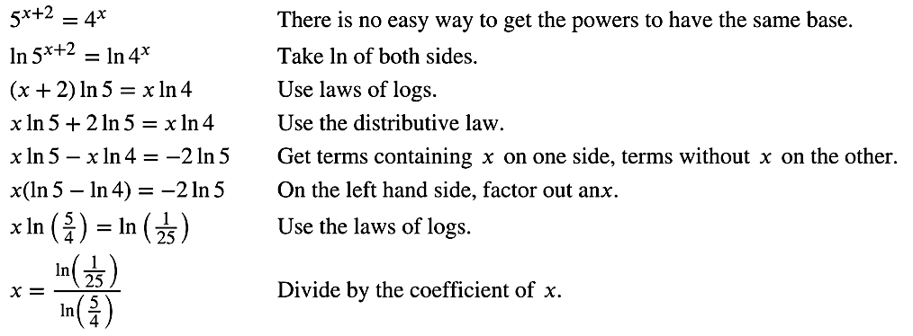

Example 3: Solve the following exponential equations.

$3^{x+2}=2^{x}$ $4^{x-1}=7^{3-x}$

**Changing Bases**

Although with technology today it is becoming obsolete, there is a way to change bases when working with logarithms. Below is the form you would use to change from any base $b$ to any other base $c$.

$$\log_{b}{(x)}=\frac{\log_{c}\left(x\right)}{\log_{c}\left(b\right)}$$

**Modeling Exponential Growth or Decay**

Earlier we looked at how to model growth or decay using different bases. Growth occurs for $b>1$ and decay occurs for $0<b<1$.

$N\left(t\right)=N_{0}b^{t}$ $A\left(t\right)=A_{0}b^{t}$

We now turn to what is called **continuous** or **uninhibited** growth or decay, which simply means the base will base $e.$ Since $e>1,$ we have a new variable $k$ which is the growth $\left(k>0\right)$ or decay $(k<0)$ rate.

$N\left(t\right)=N_{0}e^{kt}$ $A\left(t\right)=A_{0}e^{kt}$

Example 4: A population of particular bacteria is known to double every hour.

If the culture started with 10 bacteria, determine the growth rate.

Determine when there will be 500 bacteria.

How many bacteria will there be after 1 day?

Example 5: If a particular bacterium has a growth rate of 0.082, determine the doubling time in days. In other words, find the value of $t$ such that the ratio of the current amount to the original amount is 2.

**Radiocarbon Dating**

The formula for radioactive decay is important in radiocarbon dating, which is used to calculate the approximate date a plant or animal died. Radiocarbon dating was discovered in 1949 by Willard Libby, who won a Nobel Prize for his discovery. It compares the difference between the ratio of two isotopes of carbon in an organic artifact or fossil to the ratio of those two isotopes in the air. It is believed to be accurate to within about 1% error for plants or animals that died within the last 60,000 years.

Carbon-14 is a radioactive isotope of carbon that has a **half-life** of 5,730 years.

Example 6: Using $A\left(t\right)=A_{0}e^{kt}$ and the half-life of Carbon-14, determine an expression for $k$ whenever we are working with radiocarbon dating. In other words, solve for $k$ in terms of $t$, when the ratio of the current amount to the original amount is 0.5.

Using your result above, determine how old a bone is if it was found with 20% of its original Carbon-14.

**Newton’s Law of Cooling**

Exponential decay can also be applied to temperature. When a hot object is left in surrounding air that is at a lower temperature, the object’s temperature will decrease exponentially, leveling off as it approaches the surrounding air temperature. On a graph of the temperature function, the leveling off will correspond to a horizontal asymptote at the temperature of the surrounding air.

The temperature of a cooling object can be model by

$$T\left(t\right)=(T_{0}-T_{S})e^{kt}+T_{s}$$

where $T_{0}$ is the original temperature of the object, $T_{S}$ is the termperature of the surrounding air, $k$ is the cooling rate, and $t$ is a measurement of time.

Example 7: A Grande Americano was served to a customer at a temperature of $198℉$, and needs to cool to $150℉$ for the customer to avoid burns and damage to mouth tissue. If the Grande Americano has cools to $182 ℉$ after just 10 minutes while the custormer waits outside on a $65 ℉$ day, how much longer will the customer need to wait to ensure safe drinking?

You will need to find the cooling rate $(k)$ first, and then use it to solve for time $(t)$.